PWA video 14 Offline mode explained

<https://www.youtube.com/watch?v=Vz1D28zshaI>

Can emulate being off line by clicking the offline box in chrome dev tools under application

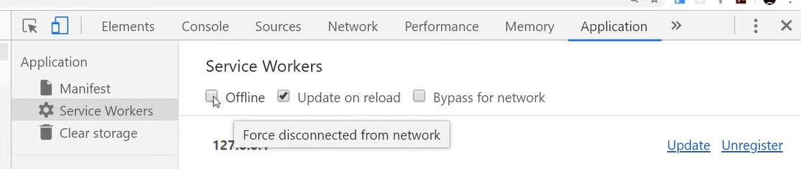

Or under network tab

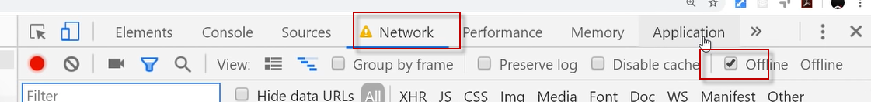

SW uses the cache API to store things locally for later user

1)Browser Cashe speeds up websites – we don’t directly control

This is where the browser cashe can be disabled

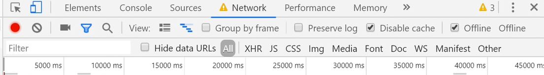

2) cashe we can control with service worker and javascript

The service worker can do pre cashe to get some needed assets if we go online.

It the browser sends network request and it is down the SW can look to see it is down and instead look for the resources in cashe and return a custom response to the browser.

This also can speed up performance when the network is not down.

